Colin Ohm

November 7, 2021

Econ 339

**Exam 1**

**Section 1 Please provide me with your R code Colin.**

1. 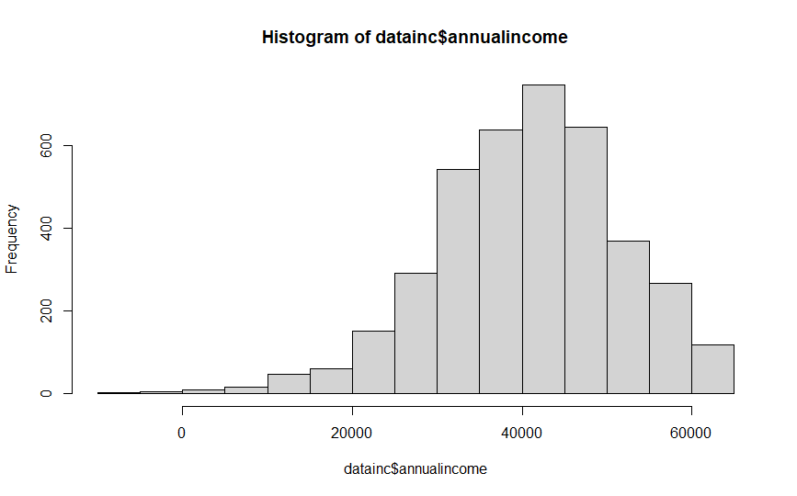
2. (Merging datasets)
3. The coefficient in this regression is 19.22. This does not show a causal relationship because there may be omitted variables that skew the regression.
4. No answer
5. No answer

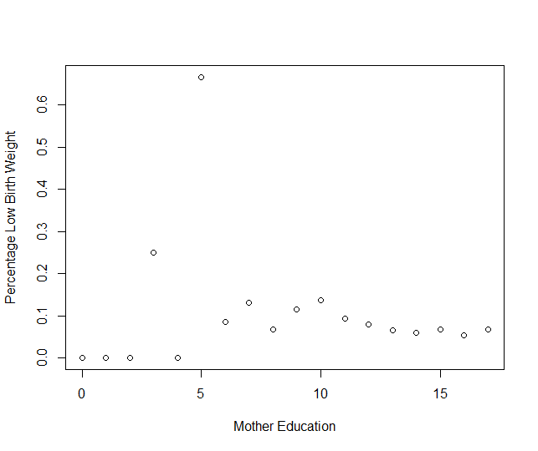

1. Constructing an indicator for mother’s education
2. The coefficient for “aboveHS” is -0.0326. This means that when a mother has a high school education, the probability of their child being of low birth weight decreases by 3.26%.
3. The coefficient for “aboveHS” when regressed with race_white, its coefficient is 0.0121. From this, it can be concluded that if a mother has a high school education, they are 1.21% more likely to be white.
4. Since a mother’s race has an impact on their education level and education level impacts infant birth weight, mother’s race must also affect infant birthweight. This means that there is an omitted variable bias when “race_white” is not included in the low birthweight regression.

**Section 2**

Question 1

1. Since the variable is greater than 0, there is a positive relationship between people who have insurance and those that go to the doctor. Meaning, if someone has insurance, they are more likely to go to the doctor more often.
2. No, we can not say that there is a causal relationship because we first need to determine if there are any omitted variable that are impacting the regression.
3. Yes, it can be concluded that the demand curve will be downward sloping. As prices decrease, the number of doctor visits increases; which creates a downward sloping curve.

Question 2

1. This suggests that there is a positive correlation between those receiving treatment and amount of doctor visits; those with health insurance are more likely to go to the doctor. This also suggests the existence of a downward sloping curve.
2. No, it does not. The positive coefficient shows that there is a relationship between those with insurance and number of doctor visits, but this does not necessarily mean that there is a causal relationship. We would need to test to find omitted variables before we can say there is a causal relationship.
3. Having insurance is a factor that leads to more doctor visits, but as explained in part b, just because there is a relationship, does not mean that insurance is the only variable that increases doctor visits.
4. The Oregon Health insurance experiment attempts to determine if Medicaid coverage enhances individuals’ well-being. The study uses a lottery system to select people for Medicaid and compares them to the control group. The results of the study found that Medicaid increases the amount of hospital visits; while decreasing out of pocket costs for low-income adults.

**Part 3**

Question 1

1. A quasi-natural experiment selects people for treatment based on social and/or social factors and are chosen based on some predetermined conditions. Considering that the only requirement for someone to have access to Medicare is being 65 years old, Medicare can be used as a quasi-natural experiment.
2. To get around this issue, the researchers attempt to solve this problem by focusing on individuals that are admitted to the hospital through the emergency department for severe illnesses. By using this subset of patients, there is no preselection bias since they will need immediate hospitalization and are unable to wait.
3. Figure 1 shows admissions through the changes in health insurance at age 65. From this figure the researchers found that there is a large increase in the fraction of patients with Medicare as their primary insurance at the age of 65 and 80% of the population is enrolled within a few weeks of becoming eligible for the program. They find that the quality of services provided to Medicare recipients have immediate life-saving impacts and health stock increases discreetly at age 65. The mortality rate also drops by 1 percentage point at the age of 65 (table V).
4. A limitation of the study they discussed is that it only focuses on one health outcome (mortality). They note that Medicare might also affect other dimensions of health as well as other patient populations.